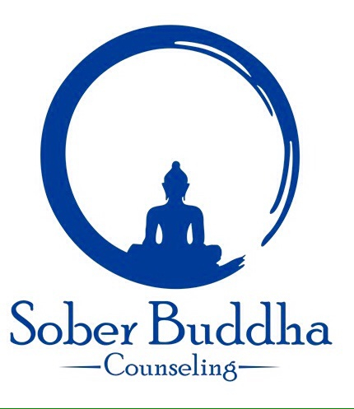
Meditation Week _____ Report Date __________

Technique used - Anapana, Noting Body Sensations, Thinking Mind, Emotions, Do Nothing
Free Floating Awareness

How many times did you meditate this week? _____
How long was the longest? The shortest? _____ _____
How many times did you meditate each day? _____
What time(s) of day did you meditate? _____ _____
Do you have family support for meditation ‘time out’? _____
How comfortable did you feel with the practice? 1- Least 10- Most _____

Where did you meditate? __________________________________________________
Was that a satisfactory environment? ________________________________________
Describe any disturbances _________________________________________________
Describe your most pleasant experience ______________________________________
Your least pleasant ________________________________________________________
What elements of the practice do you need more help with? ______________________
_________________________________________________________________________

